LAB Logbook

Week1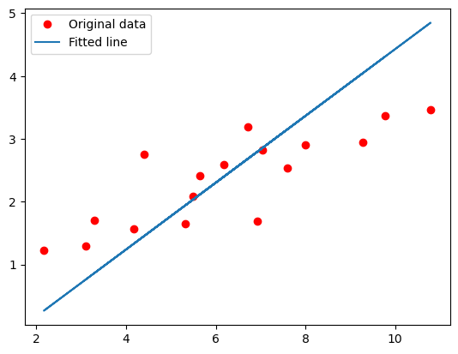

week 2

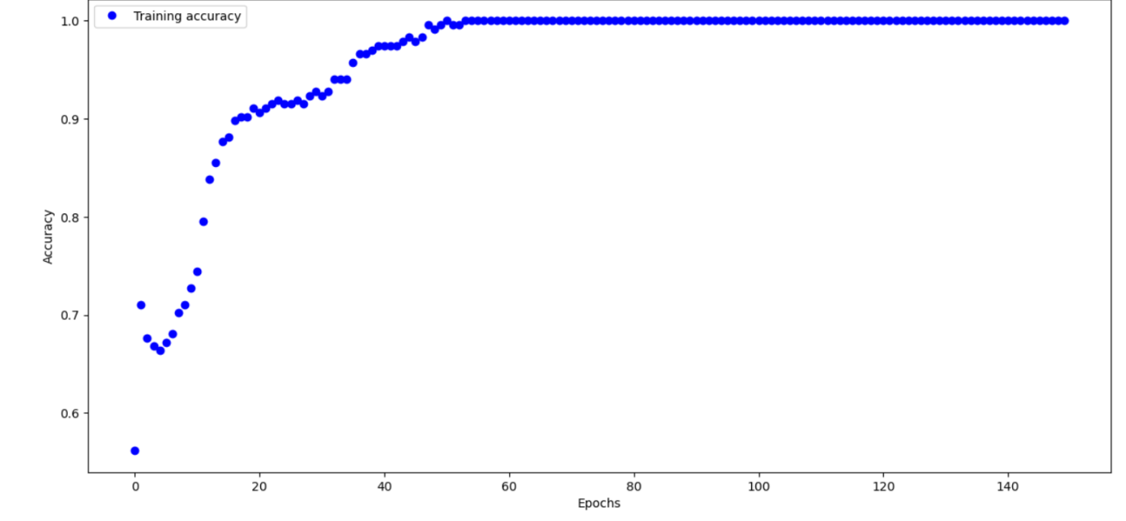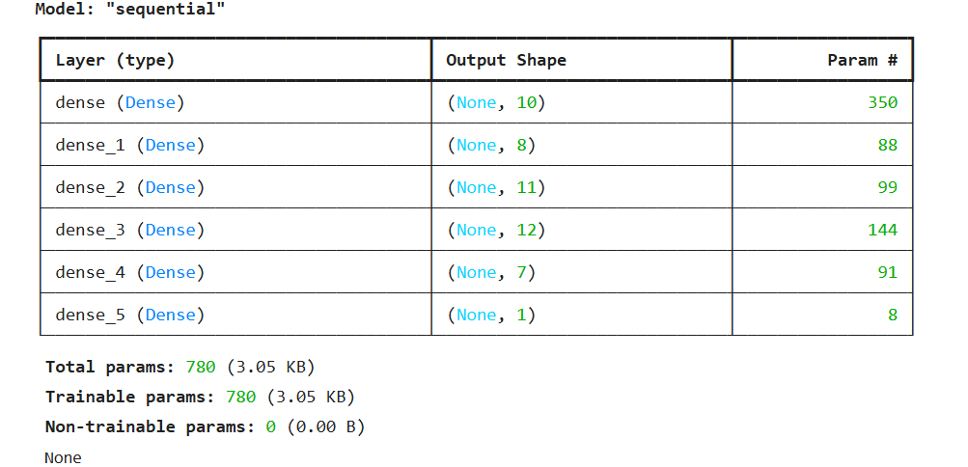

obtained accuracy is 0.8843

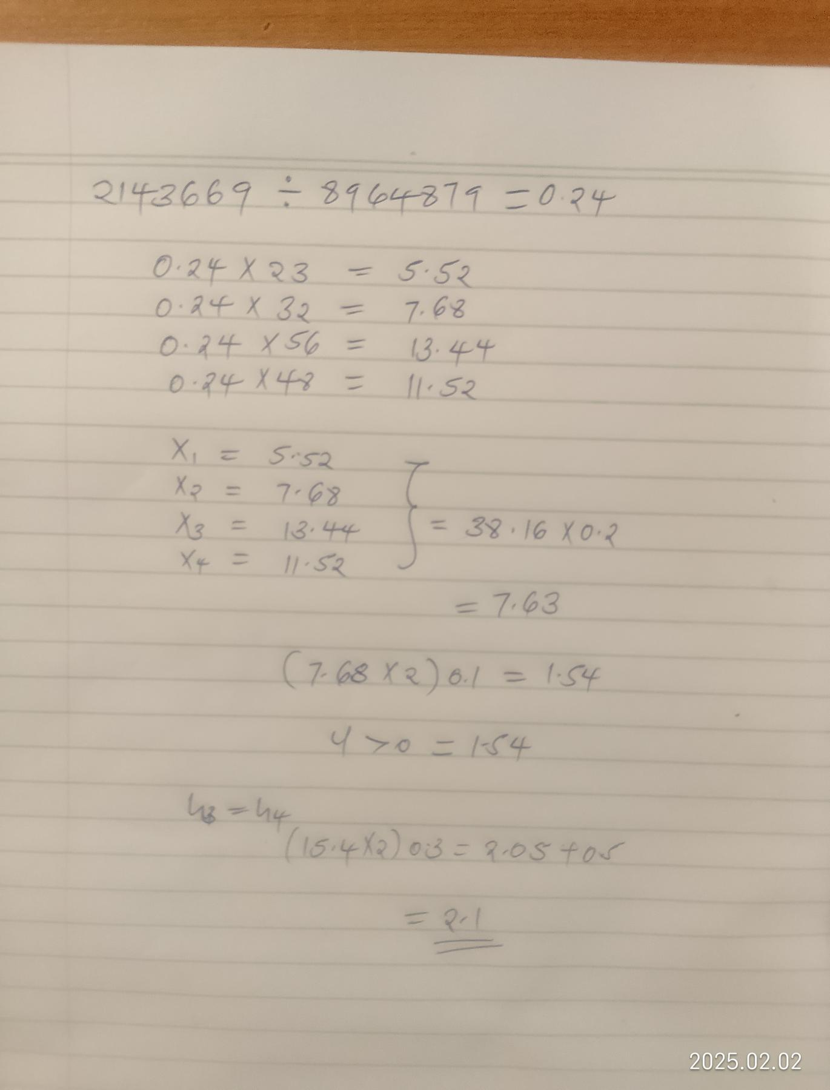

Lab 3

Lab 4

Lab 5

Lab 6

Lab 7

Lab 8

Lab 9

Lab 10

Lab 11

Lab 12